**Consumer Spending in Canada: A 12-Year Provincial Analysis of Patterns, Key Drivers, Regional Variations, and Future Trends**

Shannon School of Business, Cape Breton University

A Capstone Project on Business Analyst Research Paper

In Partial Fulfillment of the Requirements in BUSS-5802-11

Instructor: Enayat Rajabi

**Graphs and Charts of EDA and Modeling Part**

Group E

Jereika Aiko Tan- Student ID: 0264312

Luzviminda Deinla- Student ID: 0274950

Shijie Liu - Student ID: 0276875

Simarpreet Kaur- Student ID: 0285168

**Table of Contents**

1 Exploratory Data Analysis (EDA) 3

1.1 Summary Statistics of Key Variables 3

1.2 Trend Analysis: Overview of Spending Over Years 3

1.2.1 Household Spending Trends by Category (2010-2021) 3

1.2.2 Household Spending Trends by Province (2010-2021) 4

1.3 Provincial Share of Household Expenditure 4

1.4 Trend Analysis: Household Spending by Category Across Provinces 5

1.5 Impact of Economic Factors (Disposable Income and Consumer Price Index) 7

1.6 Impact of Demographic Factors (Age Groups, Household Type and Income Quintile) 10

1.7 Regional Differences on Household Spending 11

2 Predictive Model Fitting, Evaluation and Selection 13

2.1 Data Transformation and Pre-processing 13

2.2 Predictive Models Fitting and Evaluation 16

2.3 Predictive Optimizing Linear Regression Performance with Ridge and Lasso Regularization Techniques 20

# Exploratory Data Analysis (EDA)

## Summary Statistics of Key Variables

## Trend Analysis: Overview of Spending Over Years

### Household Spending Trends by Category (2010-2021)

### Household Spending Trends by Province (2010-2021)

## Provincial Share of Household Expenditure

## Trend Analysis: Household Spending by Category Across Provinces

* **Alberta**

* **British Columbia**

* **Ontario**

* **Quebec**

* **Saskatchewan**

## Impact of Economic Factors (Disposable Income and Consumer Price Index)

* **Alberta**

* **British Columbia**

* **Ontario**

* **Quebec**

* **Saskatchewan**

## Impact of Demographic Factors (Age Groups, Household Type and Income Quintile)

* **Age Group**

* **Household Type**

* **Income Quintile**

## Regional Differences on Household Spending

* **Food**

* **Housing**

* **Transportation**

* **Discretionary Goods**

# Predictive Model Fitting, Evaluation and Selection

## Data Transformation and Pre-processing

**2.1.1 One-Hot Encoding of Categorical Variables**

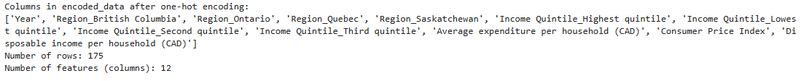

**2.1.2 Outlier Detection and Handling**

**2.1.3 Multicollinearity Analysis: Variance Inflation Factor (VIF) and Correlation Matrix Heatmap**

**2.1.4 Addressing Multicolliearity and Dimensionality Reduction**

## Predictive Models Fitting and Evaluation

* **Linear regression**

* **Random Forest Regressor**

* **XGBoost Regressor**

* **Neural Network Regressor**

## Predictive Optimizing Linear Regression Performance with Ridge and Lasso Regularization Techniques

* **Actual Vs Predicted Expenditure**

* **Residuals Vs Predicted values**

* **Distribution of residuals**

